SCIENTIFIC INQUIRY REFERENCE
The Scientific Process
- Ask a question.
- Make observations or do research to gather information.
- Form a hypothesis.
- Conduct an experiment.
- Record and analyze data.
- Conclusion.
Scenario: A group of students is assigned a Populations Project in their Ninth Grade Earth Science class. They decide to determine the effect of sunlight on radish plants. They grow 12 radish plants in 4” clay pots with 25 mL of water daily and 100 g of potting soil in 24 hours darkness, 12 hours sunlight/12 hours darkness, and 24 hours sunlight. (They use Grow-Lights to simulate sunlight.) After 5 days, they measure the height of all the plants in each pot.

1. TITLE: Communicates what your experiment is about. Since it is a title, ALL IMPORTANT WORDS SHOULD BE CAPITALIZED! This title is for your entire experiment and is also the title for your data table and graph.

The Effect of (the Independent Variable) on (the Dependent Variable)

Example: The Effect of Amount of Sunlight on the Height of Plants

2. QUESTION: A scientific question has to be able to be answered through experimentation. It should include the independent variable and dependent variable.

How does the (independent variable) affect the (dependent variable)?
What is the effect of (independent variable) on the (dependent variable)?

Example: How does the amount of sunlight affect the height of plants?
What is the effect of amount of sunlight on the height of plants?

3. HYPOTHESIS: Communicates what you think is going to happen in the experiment. The hypothesis is a possible explanation for an observation or scientific problem. A hypothesis should be written as an “If…then…” statement. Write the independent variable after the word if and tell how you will change it. Write the dependent variable after the word then and tell how you think it will change.
If (the independent variable) is (increased, decreased, changed), then (the dependent variable) will (increase, decrease, change).

Example: If the amount of sunlight is increased, then the height of the plants will increase.

4. EXPERIMENT- An experiment is an organized procedure to study something under controlled conditions. When writing the experiment you need to include an independent variable, dependent variable, and controlled variables (constants). It should also include a control setup and an experimental setup. When writing your experiment, you also need to include a materials list and a procedure. Your procedure should be clear enough for someone else to use as instructions for repeating your experiment.
- INDEPENDENT VARIABLE: (IV) Also called the Manipulated Variable. The variable you wish to test. What you purposely change or manipulate it. Expressed in your hypothesis after the word if. It should be the ONLY variable that you change during the experiment. So an experiment has ONLY ONE independent variable. Will be the CAUSE of the changes you measure. You will choose different levels of the independent variable to test.

Example: The Sunlight

LEVELS: The different values of the independent variable that you choose to test.

Example: 24 hours of darkness
12 hours of sunlight/12 hours of darkness
24 hours of sunlight

TRIALS: The number of times each level is repeated.

Example: 12 radish seeds in each pot = 12 trials for each level of sunlight

- DEPENDENT VARIABLE: The variable is the factor that you measure to gather results. It responds to the independent variable. Also called the Responding Variable. Expressed in your hypothesis after the word then. Will be the EFFECT of the action you took.

Example: The Height of the Plants

- CONSTANTS: All the other variables that remain the same for all the trials. Must be quantified (include numbers). All factors should remain constant except for the independent variable. Also called controlled variables, but they are NOT the control for the experiment.

Example: 4” pots
100g potting soil
25 mL water daily

- CONTROL SETUP: One of the levels of Independent Variable that does NOT contain the independent variable OR the level that is most natural or most normal. Testing this level gives you a way to detect hidden variables.

Example: The level in the above scenario that most acts like NORMAL for plants would be the 12 hours sun/12 hours dark. You are comparing the 24 hours darkness and 24 hours sunlight to the normal situation for plants.

- EXPERIMENTAL SETUP(S): The other levels of independent variable that you are testing are your experimental setups.

Example: 24 hours of darkness
- hours of sunlight

- RECORD AND ANALYZE DATA: See Data Tables and Graphs reference.

- CONCLUSION: A conclusion should state the relationship that you found between your independent and dependent variables. It should also state if your hypothesis was or was not supported by your data. The results of an experiment cannot prove that a hypothesis is correct. Rather, the results either support or do not support the hypothesis. Valuable information is gained even when your hypothesis is not supported by your results.

Example: During my experiment, the (IV) (describe how you changed the IV) and the (DV) (describe how the DV responded). This data (did/did not) support my hypothesis.

- 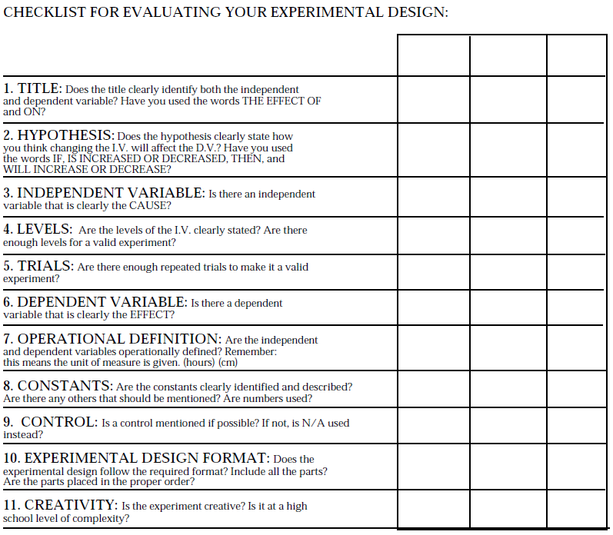
Quantitative data can be expressed in numbers and include records of time, temperature, mass, distance, and volume.
Qualitative data include descriptions of sights, sounds, smells, and textures.
Data tables and graphs are useful tools for both recording and communicating scientific data. You can use a data table to organize and record the measurements that you make.

