Chemistry
Chapter 1 Atomic Structure and the Periodic Table
1.1 Atoms are the smallest form of elements. (pp. 9-16)
- All matter is made of atoms of about 100 elements. Every element has a unique name and symbol. An element is a substance that contains only one kind of atom. These elements may be combined in nature or by man to produce compounds that make up the living and non-living substances in the environment. Living and once living things are made mostly of compounds containing the elements carbon, hydrogen, and oxygen.
- Each element is made of a different atom. Atoms are extremely small, but are made of still smaller particles: protons, neutrons, and electrons. At the center of an atom is the nucleus, which contains almost all of the atom’s mass. The nucleus contains protons and neutrons. Protons have a positive charge and neutrons have no charge. Protons and neutrons have approximately the same mass, 1 atomic mass unit (amu). In a cloud around the nucleus are electrons. The electrons can be found in shells (energy levels) around the nucleus. The first energy level can hold up to two electrons. No more than eight electrons can be in the second energy level. For the elements in the first few periods, the third energy level is full when it contains eight electrons. Electrons are much smaller than protons or neutrons. Electrons have almost no mass, so it is not calculated into the mass of the atom. The figure below shows the positions of the electron cloud and the nucleus in an atom.
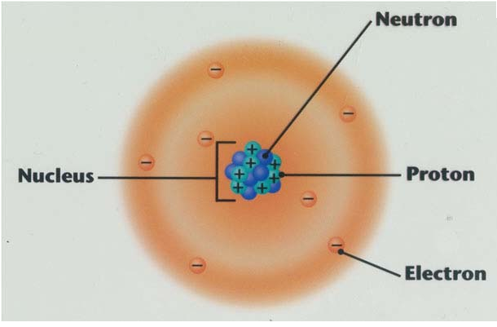
The atomic number is the number of protons in an atom. Each element has a different number of protons and, therefore, a unique atomic number. Atomic mass number is the number of protons plus the number of neutrons in the nucleus. It tells the mass of the atom. Since electrons have such little mass, they are not calculated into the mass of the atom. However, the atomic mass is not a whole number. It is a decimal because every element has isotopes. Isotopes are atoms of an element with different numbers of neutrons. Since isotopes occur in various amounts in nature, the atomic mass of an atom is the average mass of all the elements isotopes. The number of electrons is equal to the number of protons in an uncharged (balanced) atom. While a Bohr diagram is not completely accurate in representing the structure of an atom, it effectively models the basic structure of simple elements. An example Bohr diagram is shown below.
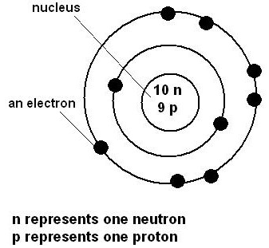
1.2 Elements make up the periodic table. (pp.17-25)
- Elements can be organized by similarities. Many scientists thought the elements could be organized by their properties. Dmitri Mendeleev made the first periodic table. Mendeleev used atomic mass to order the elements and placed elements with similar properties in the same rows.
- The periodic table organizes the atoms of the elements by properties and atomic number. The modern periodic table is organized by atomic number. The squares on the periodic table give the following information about each element: atomic number, chemical symbol, name, average atomic mass. It also indicates state at room temperature.
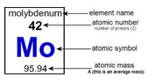
- The location of an element on the periodic table can reveal information about an element. A group or family is a column of elements. The elements in a group have similar properties. They also have the same number of electrons in their outer energy level. These outer electrons are called valence electrons. The number of valence electrons increases by one as you go from left to right across the periodic table (skipping the transition metals). A period is a row of elements. These elements do not have similar properties, but they have the same number of energy levels. The number of energy levels is equal to the number of the period.
1.3 The periodic table is a map of the elements (pp. 26-33)
- The periodic table has distinct regions. Position in the periodic table reveals something about how reactive an element is. Elements in Groups 1 and 17 are the most reactive. Elements in Group 18 are the least reactive. The number of valence electrons determines how reactive an element is.
- Most elements are metals. Metals are usually shiny, often conduct electricity and heat well, and can be easily shaped and drawn into a wire. Alkali metals and alkaline earth metals are at the left of the periodic table and are very reactive. Transition metals are near the center of the periodic table. Rare earth metals are in the two rows of metals shown outside the main body of the periodic table.
- Nonmetals and metalloids have a wide range of properties. Nonmetals appear on the right side of the periodic table. They include elements with a wide range of properties. Nonmetals are poor conductors of heat and electricity, break easily, and are dull in appearance. Metalloids lie between metals and nonmetals in the periodic table. They have characteristics of both.

